Assignment #4

Question #1 :

#include<iostream>

#include<cstdlib>

#include<time.h>

using namespace std;

void myfunction(int dice1, int dice2, int sum, int count,int num)// Making a void function //

{

srand(time(0));//Generating random Number//

sum = -1;

while (num!=sum)//Loop for that Numbers //

{

dice1 = rand() % 6 + 1;

dice2 = rand() % 6 + 1;

sum = dice1 + dice2;//sum//

cout << sum <<" ";//Displaying sum//

count++;

}

cout << "\n";

cout << "The Number of turns is = " << count;//No of Terms //

cout << endl;

}

int main()

{

int num, dice1=0, dice2=0, count=0,sum = -1;//itializing somr=e variables //

cout << "Enter the Number : ";//taking Input//

cin >> num;

myfunction(dice1, dice2, sum, count, num);//calling the function//

system("pause");

return 0;

}

# Output:

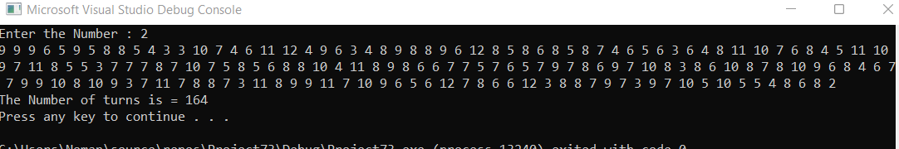

Question #2:

#include<iostream>

using namespace std;

void largest(int arr[6])//Making function and Passing 1D array as a arguments//

{

int Max=0,i;

for ( i = 0; i < 6; i++)//This For loop will goes to each number //

{

if (arr[i] > Max)//And This Condition Check the Largest Number //

{

Max = arr[i];

}

}

cout << "The largest is " << Max << endl;//displaying //

}

void smallest(int arr[6])

{

int smallest = arr[0];//Intilizing index of array with zero//

for (int i = 0; i < 6; i++)

{

if (arr[i] < smallest)//This Condition is For Smallest number //

{

smallest = arr[i];

}

}

cout << "The smallest is " << smallest << endl;

}

int main()

{

int arr[6] = { 9,8,5,4,6,2 };//taking an 1d array

largest(arr);

smallest(arr);

system("pause");

return 0;

}

Output:

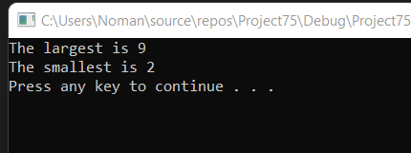

Question#3:

#include<iostream>

#include<ctime>

using namespace std;

void radius(int x1, int x2, int y1, int y2)//Making a function of Type Void//

{

double radius;

cout << "Enter the value of x1 to find radius:";//Taking Input//

cin >> x1;

cout << "enter the value of x2 to find radius :";

cin >> x2;

cout << "enter the value of y1 to find radius :";

cin >> y1;

cout << "Enter the value of y2 to find radius :";

cin >> y2;

radius = ((x2 - x1)*(x2-x1)) + ((y2 - y1)*(y2-y1));//Making formula To find radius//

cout << sqrt(radius) << endl;//taking square root of that radius//

}

int area(double radius)//To find area we have formula pi*r*r//

{

double area1, pi = 3.14;

cout << "Enter the radius to find area : ";

cin >> radius;

area1 = (3.14)*(radius*radius);//This is formula to find area//

cout << "The area is : " << area1 << endl;

return area1;

}

void circumference(double radius)//Making function for circumfrence//

{

double fcircum;

cout << "Enter the radius to Find circumference :";

cin >> radius;

fcircum = (2 * 3.14)*radius;

cout << "The circumference of the Circle is : " << fcircum;

cout << "\n";//for next line//

}

void distance(int x1, int x2, int y1, int y2)//Making a function of Type Void//

{

double distance;

cout << "Enter the value of x1 to find distance :";//Taking Input//

cin >> x1;

cout << "enter the value of x2 find distance :";

cin >> x2;

cout << "enter the value of y1 find distance :";

cin >> y1;

cout << "Enter the value of y2 find distance :";

cin >> y2;

distance = ((x2 - x1)*(x2 - x1)) + ((y2 - y1)*(y2 - y1));

cout << "The distance between two points is : " <<sqrt (distance) << endl;//Displaying Distance//

}

int main()

{

int a=0, b=0 ,c=0, d=0,g=0,r=0,num1=0,num2=0,num3=0,num4=0;//Intializing some variables with zero//

radius(a, b,c, d);//Calling the radius Functio//

area(g);//calling the area function//

circumference(r);//calling the circumference function//

distance(num1, num2, num3, num4);//calling the distance function//

system("pause");

return 0;

}

Output:

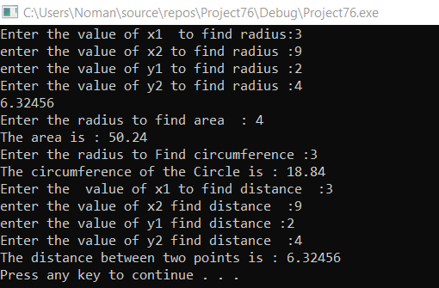

Question#4:

#include<iostream>

#include<fstream>

#include<string>

using namespace std;

int main()

{

ifstream in;

ofstream out;

string name[3],section[3];

int rollNo[3], i = 0;

float gpa[3];

out.open("file.txt",ios::app);

/*name = "My Name is umer ";

out << name;*/

out.close();

in.open("file.txt");

char ch;

//string name;

while (!(in.eof()))

{

in >> name[i] >> rollNo[i] >> gpa[i] >> section[i];

i++;

}

for(int i=0;i<3;i++)

cout << name[i] << " " << rollNo[i] << " " << gpa[i] << " " << section[i] << endl;

rollNo[1] = 9104;

for (int i = 0; i < 3; i++)

cout << name[i] << " " << rollNo[i] << " " << gpa[i] << " " << section[i] << endl;

}

Output:

